# Global overview of past current and future impacts of ICTs

Video streaming is an entertainment service delivered over the internet. As such, it is heavily dependent on elements of the ICT(The Information and Communication Technology) sector. Video streaming is reliant on the ICT and E&M sectors to deliver content into the home, and within the ICT system there are multiple touch points. To understand the emissions of streaming it is helpful to realize how video entertainment (and the media industry in general) has been digitizing.

The digital technology today represents 2.5% of carbon footprint at national level (manufacturing and use phases included). And according to the report of senate, the footprint will increase by 60% to 6-7%. From the report *Rapport Annuel du Registre des Déchets d’équipements Electriques et Electroniques* in 2021, we can know that more than 1.2 billion pieces of electrical and electronic equipment were placed on the market in 2019, an increase of 25% compared to 2018.

## ICT’s carbon footprint in 2020

The emission of the ICT sector is almost five times smaller than the global footprint of the iron and steel sector, and smaller than many other large industries.

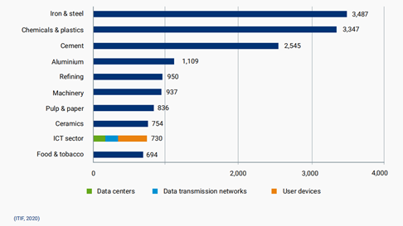

The current and historical emissions are now considered in more detail by the sub sectors within the ICT boundary. As mentioned above, these are: data centers, networks, end-user devices and (Entertainment and Media) E&M.

## Historical carbon footprint of ICT

The carbon emissions of the ICT sector increased from the early 1990s to 2010 (GeSI, 2008; Malmodin et al., 2013; Malmodin, 2018a). However, this emissions trend has largely plateaued, remaining relatively stable over the last decade, despite network data volumes continuing to grow year on year.

There is an evidence that energy and GHG emissions are not directly linked to data traffic growth.

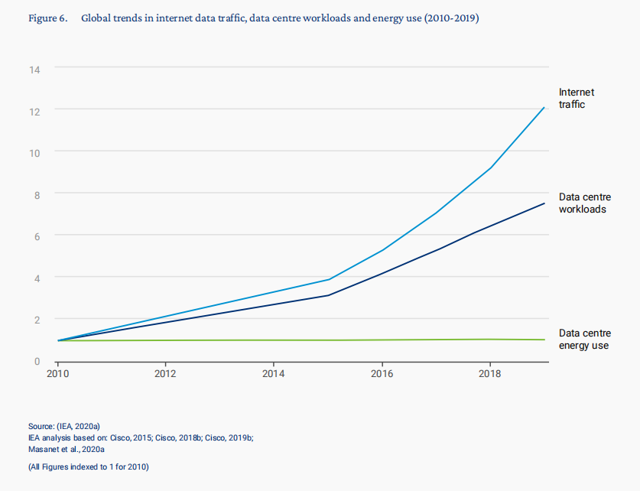

It is widely acknowledged that **energy efficiency** of ICT and **computing equipment** has historically doubled every one to three years (Kamiya, 2020; Koomey et al., 2011a, Koomey and Naffziger, 2016), and similarly **energy efficiency of networks** has historically doubled approximately every two years (Aslan et al., 2018), see box below. **This sustained efficiency has helped to stabilize** ICT’s carbon footprint, even as the sector has continued to expand.

Overall, it is clear that internet data traffic along with data center demands have grown steadily in the past decade. The growth of data traffic has not resulted in a proportional growth in the energy consummation of ICT.

## Future trends in ICT carbon emissions footprint

Forecasting future ICT emissions is fraught with uncertainty. It is influenced by both the increasement of traffic and energy efficient. However, even if there are overall increases in energy consummation, the total emissions are likely to fall, with the development of ICT technology and decarbonization of electricity grid.

Le visionnage de vidéos en streaming sur des écrans de petite taille est le moins impactant. Le visionnage sur téléviseur d’un film en DVD versus un streaming « haute définition » représente plus d’impacts sur le changement climatique, mais sensiblement moins d’impacts sur les ressources.

Ainsi, le numérique représenterait aujourd’hui 2,5 % de l’empreinte carbone au niveau national (phases de fabrication et d’utilisation comprises).

En outre, selon le rapport de la mission d’information sur l’empreinte environnementale du numérique du Sénat, l’empreinte carbone de celui-ci pourrait augmenter de manière significative si rien n’est fait pour la limiter (+ 60 % d’ici à 2040 soit 6,7 % de l’empreinte carbone nationale).

La consommation de biens électroniques nationale connaît par ailleurs une croissance de plus en plus soutenue. Ainsi, d’après la dernière version du « Rapport annuel du registre des déchets d’équipements électriques et électroniques » de l’ADEME publié en janvier 2021 (ADEME 2021b), plus de 1,2 milliard d’équipements électriques et électroniques ont été mis sur le marché en 2019, en croissance de 25 % par rapport à 2018.

According to The Shift Project, a French think tank that advocates for the shift to a post-carbon economy, the following is the approximate breakdown of data consumption for various online activities per 100 GB of data consumed:

Video on demand: 30 GB

Video games: 9 GB

Music streaming: 0.5 GB

Social media: 10 GB

[Pornography: 22 GB](https://theshiftproject.org/)